Pró-reitoria de Pesquisa, 25 de novembro de 2011.
A Pró-reitoria de Pesquisa está promovendo seminários que marcam a visita à USP de dois diretores de programa do National Science Foundation. Esta iniciativa visa criar uma sinergia de discussão sobre temas de interesse mútuo que possam no futuro culminar em propostas diretas para a comunidade acadêmica da USP.
Os setores envolvidos estão mais próximos da área de Sistemas Dinâmicos, Materiais e Novos Desafios tecnológicos e de Engenharia, mas devem-se olhar estes tópicos de forma aberta e multidisciplinar.
Mesmo nesta época de muitas tarefas de docência e administrativas não se pode perder a oportunidade de estabelecer contatos que certamente serão de grande valia para a pesquisa.
Em nome dos coordenadores gerais da visita solicito que se divulguem os seminários.
Marco Antonio Zago
Pró-reitor de Pesquisa

Seminários Gerais no campus São Paulo
Dia 1 de dezembro, 10 h
Anfiteatro da Enga. Mecânica, Escola Politécnica
Rua Prof. Mello Moraes, 2231, Cidade Universitária

Materials Research at NSF: An Overview of the Materials and Surface Engineering Program
Clark V. Cooper
Director, Materials and Surface Engineering Program, National Science Foundation
The materials and surface engineering program at the National Science Foundation support basic research that is intended to advance the state of knowledge and understanding through discovery of the interrelationships among composition, structure, and properties, throughout the spectrum of length and time scales. It accepts proposals that are purely experimental, purely modeling/simulation, purely theoretical, and combinations thereof. This presentation will include an overview of both NSF and the materials and surface engineering program, the review of a small number of example grants that represent the program, and will culminate with the identification and discussion of strategic future directions and objectives that the PD is likely to pursue, including research at the intersection of the life and physical sciences, the pervasive use of ab initio modeling as an instrument to promote discovery, and research opportunities in Mg and its alloys. It is hoped that the seminar presentation will assume an informal format that encourages interaction among the presenter and members of the audience in order to maximize the exchange of information that is most useful to the audience.

Research Funding Opportunities at National Science Foundation (NSF)

Eduardo A. Misawa

Civil, Mechanical and Manufacturing Innovation

Abstract: Engineers excel bridging the gap between what the mind can imagine and what the laws of nature allow. Engineers advance the frontier of science and engineering and apply fundamental science to design and develop new devices and engineered systems to solve societal problems. The National Science Foundation promotes the progress of engineering in the United States in order to enable the Nation's capacity to perform. Its investments in engineering research and education aim to build and strengthen a national capacity for innovation that can lead over time to the creation of new shared wealth and a better quality of life. This talk will discuss recent trends in funding by the National Science Foundation and will provide an overview of funding opportunities in the different directorates as well as in cross-disciplinary activities supported by the NSF. This presentation will emphasize cross-disciplinary funding opportunities and will touch upon potentially transformative projects and cyber-related new funding opportunities at NSF.

Seminários Gerais no campus São Carlos
Dia 2 de dezembro
Repete-se o ciclo de palestras na USP-São Carlos

Program Responsibilities:
Domestic Nuclear Detection Office-National Science Foundation Academic Research Initiative (ARI)
EMERGING FRONTIERS IN RESEARCH AND INNOVATION 2012
Materials and Surface Engineering (MSE)
Physical and Engineering Sciences in Oncology
Software Infrastructure for Sustained Innovation
Biography:
Clark V. Cooper is Director of the Materials and Surface Engineering program at the National Science Foundation, a position that he has held since February 2006. At NSF, he has been active in championing a new focus on Simulation-Based Engineering and Science, including leadership in the planning and execution of a two-continent study and a strategic directions workshop. Prior to his commencement at NSF in early 2006, he was a Principal Scientist at United Technologies Research Center in Connecticut, where he pursued fundamental and applied research in the general area of surface science and engineering, focusing on the use of various physical (PVD) and chemical (CVD) vapor deposition processes to synthesize hard and protective coatings and the application of thermo-chemical processes to improve the properties of the surfaces of engineering materials. He and his colleagues have demonstrated the effectiveness of these and other surface modification techniques, including high intensity plasma ion processing (HIPIP), to impart remarkable improvements in hardness and wear and corrosion resistance of engineering alloys and in the surface and bending fatigue durability of power transmission gears. He and his collaborators demonstrated the successful application of first-principles modeling, especially at the atomistic level, to understand and design more effective additive compounds for synthetic lubricants and developed novel approaches to integrate length and time scales for innovative multi-scale models. In addition, he has contributed to advancements in the understanding and to improvements in the properties of materials and coatings for use at high temperature and in other extreme environments. Dr. Cooper holds a B.S. from University of Illinois at Urbana-Champaign and a Ph.D. in Materials Science and Engineering from Northwestern University.
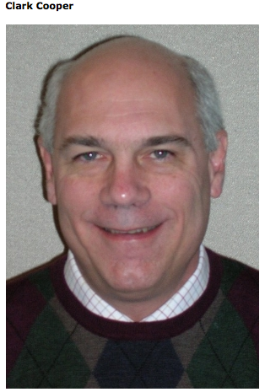
Organization: (EFRI) Title: Program Director Organization: (CMMI) Title: Program Director
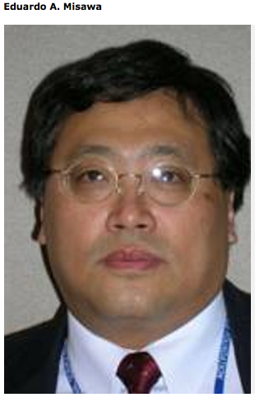
Organization: (EFRI) Title: Program Director Organization: (CMMI) Title: Program Director Organization: (EEC) Title: Member(Division of Civil, Mechanical and Manufacturing Innovation, Directorate for Engineering)
Program Responsibilities:
Cyber-Enabled Discovery and Innovation (CDI)
Dynamical Systems (DS)
Explosives and Related Threats: Frontiers in Prediction and Detection (EXP)
Software Infrastructure for Sustained Innovation
Biography:
Eduardo Misawa has a B.Sc. and M.Sc. degrees from University of Sao Paulo (1979 and 1983) and Ph.D. degree from the Massachusetts Institute of Technology (MIT, 1988), all in Mechanical Engineering with concentration in Dynamics and Control. He is currently a Program Director in the Directorate for Engineering at the National Science Foundation. His research experience includes Nonlinear Dynamics, Nonlinear Control, Robust Control, Vibrations, Mechatronics, Nanotechnology, Precision Engineering, Vehicle Dynamics, Fluid Power Control, Bioinformatics, Biotechnology and Biomedical Engineering.

Coordenação geral da visita:
Emilio Carlos Nelli Silva - ecnsilva@usp.br
José Reinaldo Silva - reinaldo@usp.br

